

Mathematics Specialist Unit 2 2021

Test 4

Trigonometric Identities and Matrices

Name: ______________________ Total Marks:__________

Task type: Response

Time allowed for this task: 60 minutes, in-class, under test conditions
Section One: Calculator-free 42 minutes ( 39 marks)
(3 Minutes Reading – 40 Minutes Working)
Section Two: Calculator-assumed 16 minutes ( 15 marks)
(2 minutes Reading - 15 minutes working)

Materials required: Calculator with CAS capability (to be provided by the student)

Standard items: Pens (blue/black preferred), pencils (including coloured), sharpener, correction fluid/tape, eraser, ruler, highlighters

Special items: Drawing instruments, templates, notes on one unfolded sheet of
A4 paper, and up to three calculators approved for use in the WACE examinations
Formula sheet

Marks available: 54 marks

Task weighting: 6%

Section One : Calculator Free 39 Marks
Time Allowed 30 minutes

Question 1 (8 marks)

For the following matrices
$A=\left[\begin{matrix}4 & -1 \\ 5 & 0\end{matrix}\right]$ $B=\left[\begin{matrix}6 & -2 \\ 7 & -2\end{matrix}\right]$ $C=\left[\begin{matrix}-2 \\ 7\end{matrix}\right]$

Determine the following, if not possible explain why.
- $2B$

- $A-C$

- $3A-B$

- $AB$

- $AC$

- $B^{-1}$

Question 2 (3 marks)

Use a matrix method to solve the system of equations $5x-2y=14$ and $9x-4y=24$.

Question 3 (6 marks)
Find all the solutions to the following equations

- $2sin{x}=\sqrt{3}$

- $\sin{x}=\cos{x}$

Question 4 (8 marks)

Let $A=\left(\begin{matrix}1 & 0 \\ 5 & 1\end{matrix}\right), B=\left(\begin{matrix}p & 6 \\ 2 & p+1\end{matrix}\right), C=\left(\begin{matrix}-2 \\ 1\end{matrix}\right)$ and $D=\left(\begin{matrix}-8 \\ 4\end{matrix}\right)$, where $b$ is a constant.

- Determine matrix B if

  - $BC=D$
(2 marks)

  - $B$ is singular
(3 marks)

- Use a matrix method to determine $X$ if $3X=4C-AX$. (3 marks)

Question 5 (7 marks)

- State the exact value of $\sec{\frac{π}{3}}$
(2 marks)

- Given that $cosec θ=\begin{matrix}5 \\ \overline{4}\end{matrix}$ and $\frac{π}{2}≤θ≤π$, state the exact value of $\sec{θ}$
(3 marks)

- Sketch the graph of $y=2\operatorname{cosec}{(x+\frac{π}{2})}$ on the grid below.
(3 marks)

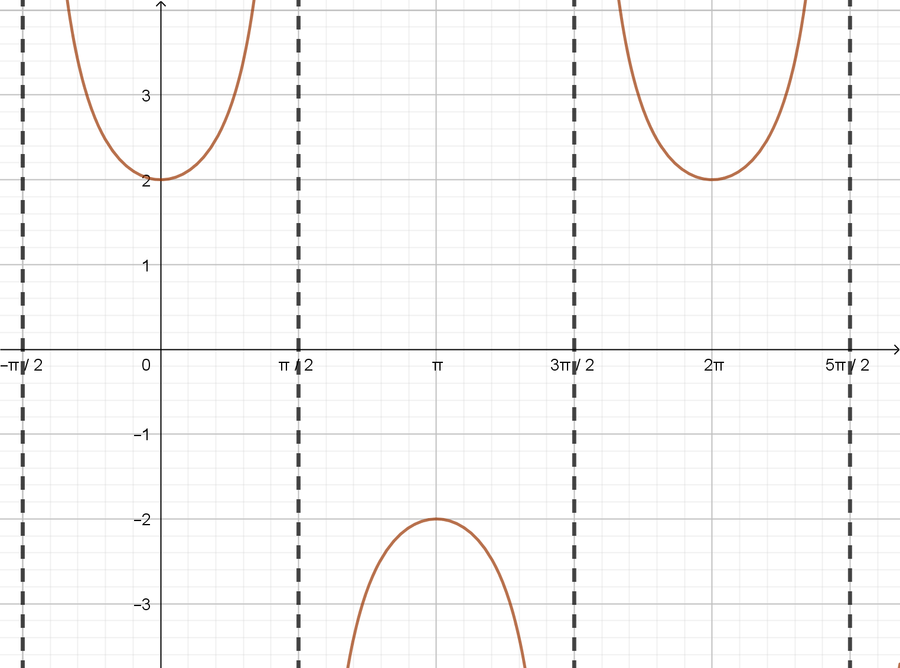

Question 6 (7 marks)

- Use the identity $\cos\left(A±B\right)=\cos{A}\cos{B}∓\sin{A}\sin{B}$ to prove $\cos{2A}=2\cos^{2}A-1$
(3 marks)

- Hence solve $\cos{2A}=\cos{A}$, for $-π≤A≤π$.
(4 marks)

Section Two : Calculator Assumed 15 Marks
Time Allowed 30 minutes Name:_______________________

Question 7
(5 marks)

The function $f\left(x\right)=a\tan{(b(x+c)}$ is graphed below.

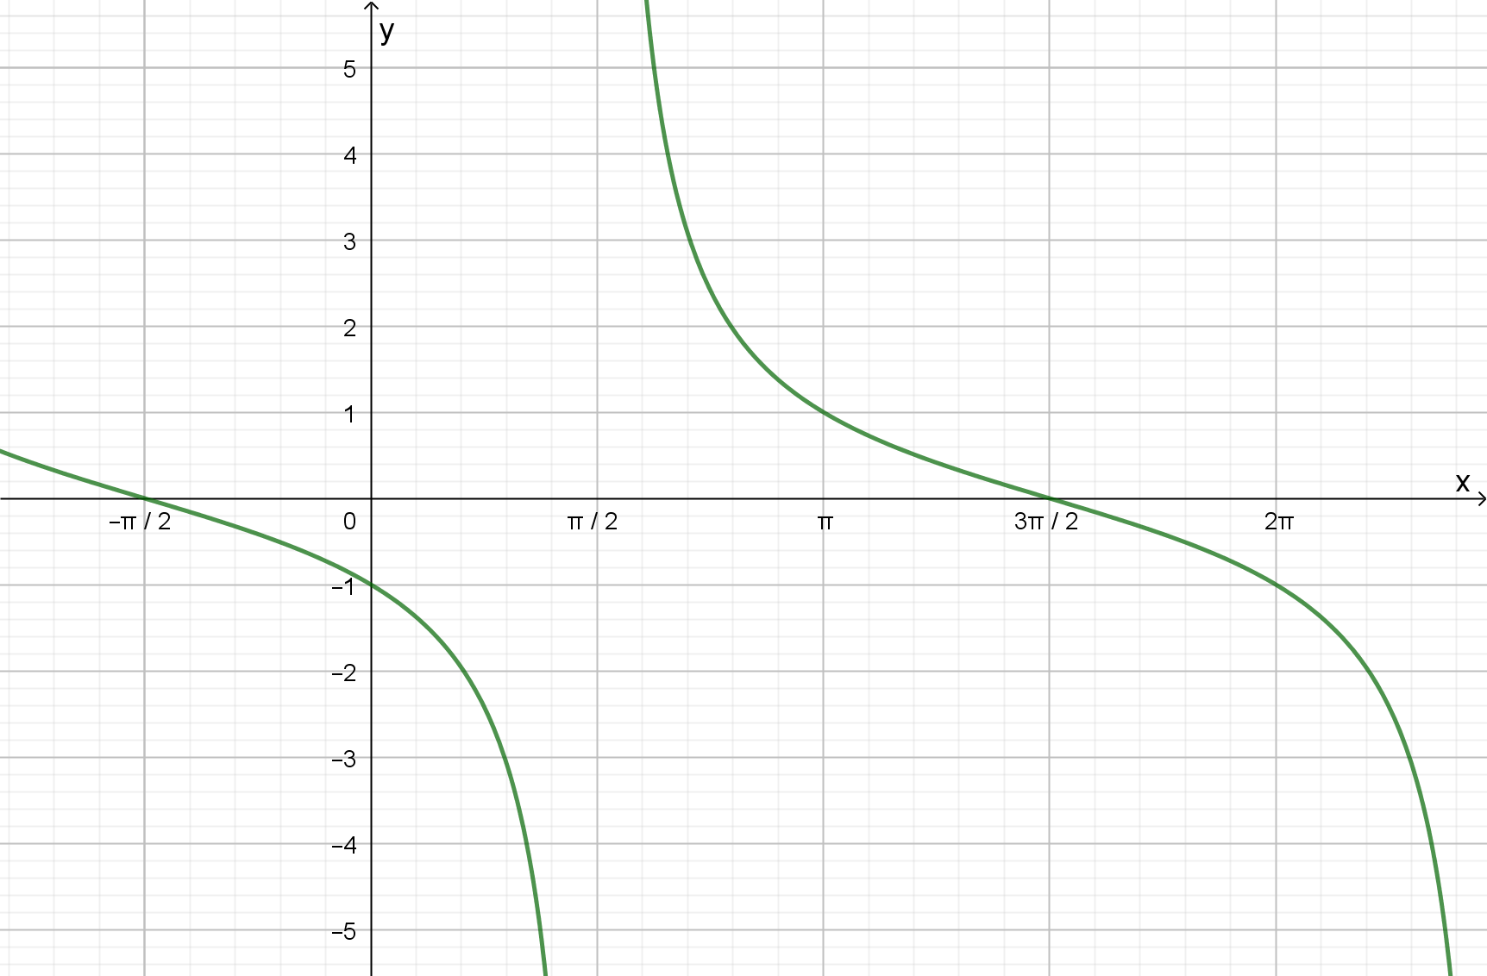
- Determine the values of the constants $a, b,$ and $c$.
$a=-1 b= 0.5 c=π/2$

- Find the general solution for $f(x)=1$

Question 8
(10 marks)
Starting at midnight ($t=0$), the temperature $T$ at a campsite was observed to vary sinusoidally over the course of the day, reaching a high of $17.9°$C at $1$ pm after a low of $-2.3°$C at $1$ am. Let $t$ be the time in hours from midnight.

- Use the above information to sketch a graph showing how $T$ varies with $t$ during the day.
(3 marks)

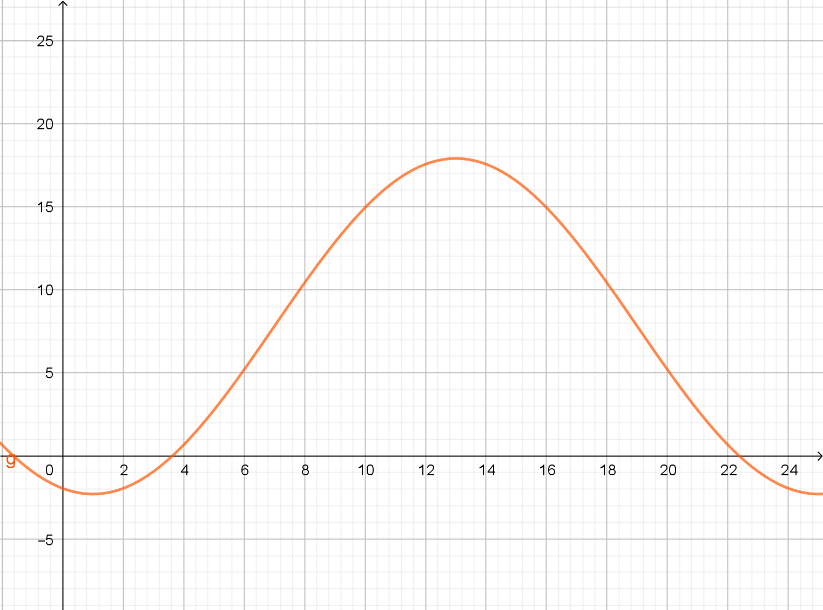

- Determine an algebraic model for $T$ as a function of $t$. (4 marks)

Solution (Using cos)
Model with $T=c-a\cos\left(k\left(t+b\right)\right)$
Using period: $k=\frac{2π}{24}=\frac{π}{12}$
Amplitude: $a=\frac{17.9-(-2.3)}{2}=10.1$
Mean temp: $c=17.9-10.1=7.8$
Phase shift: $b=-1$

$$T=7.8-10.1\cos\left(\frac{π}{12}\left(t-1\right)\right)$$

Specific behaviours
indicates period, value of $k$
ü amplitude $a$ and mean $c$
ü phase shift
ü correct model

Solution (Using sin)
Model with $T=a\sin\left(k\left(t+b\right)\right)+c$
Using period: $k=\frac{2π}{24}=\frac{π}{12}$
Amplitude: $a=\frac{17.9-(-2.3)}{2}=10.1$
Mean temp: $c=17.9-10.1=7.8$
Phase shift: $b=-7$

$$T=10.1\sin\left(\frac{π}{12}\left(t-7\right)\right)+7.8$$

Specific behaviours
indicates period, value of $k$
ü amplitude $a$ and mean $c$
ü phase shift
ü correct model

- Use your model to determine the time of the day that the temperature at the campsite falls below $0°$C. (3 marks)

